Ratio and Proportion

Ratio
# Source: AI Source: Provided by: [Data Path: Persons Table -> ID Column: 1, Name_En Column: Motasem Essam] -> From: [ChatGPT] on [7/15/2026]
A Ratio is a comparison between two or more quantities that shows how many times one quantity contains or is contained in another. Ratios compare quantities of the same or different units and describe their relative sizes.
Ratios are fundamental in arithmetic and are widely used in algebra, geometry, trigonometry, statistics, finance, engineering, science, computer science, and everyday life.

Definition
# Source: AI Source: Provided by: [Data Path: Persons Table -> ID Column: 1, Name_En Column: Motasem Essam] -> From: [ChatGPT] on [7/15/2026]
A ratio compares two quantities using division.
The ratio of two numbers $a$and $b$(where $b≠0$) is
$$\boxed{a:b}$$
or equivalently
$$\boxed{\frac{a}{b}}$$

Visualizing a Ratio
# Source: AI Source: Provided by: [Data Path: Persons Table -> ID Column: 1, Name_En Column: Motasem Essam] -> From: [ChatGPT] on [7/15/2026]
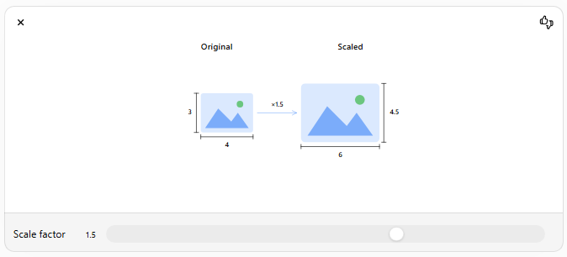
A ratio describes how one quantity changes relative to another while preserving the same proportion.

Ratio Formula
# Source: AI Source: Provided by: [Data Path: Persons Table -> ID Column: 1, Name_En Column: Motasem Essam] -> From: [ChatGPT] on [7/15/2026]
For two quantities
$$a$$
and
$$b,$$
the ratio is
$$\boxed{a:b=\frac{a}{b}}$$
provided
$$b≠0.$$

Ways to Write Ratios
# Source: AI Source: Provided by: [Data Path: Persons Table -> ID Column: 1, Name_En Column: Motasem Essam] -> From: [ChatGPT] on [7/15/2026]
The same ratio may be written in several forms.
Example:
The ratio of
$$4$$
to
$$5$$
can be written as
- $4:5$
- $\frac{4}{5}$
- "4 to 5"

Terms of a Ratio
# Source: AI Source: Provided by: [Data Path: Persons Table -> ID Column: 1, Name_En Column: Motasem Essam] -> From: [ChatGPT] on [7/15/2026]
For
$$7:9$$
- First term:
$$7$$
- Second term:
$$9$$

Simplifying Ratios
# Source: AI Source: Provided by: [Data Path: Persons Table -> ID Column: 1, Name_En Column: Motasem Essam] -> From: [ChatGPT] on [7/15/2026]
Ratios are simplified by dividing every term by their Greatest Common Divisor (GCD).

Example
Simplify
$$12:18$$
Greatest common divisor:
$$6$$
Divide both terms:
$$12:18=2:3$$

Example
Simplify
$$20:50$$
Divide by
$$10 \\ 20:50=2:5$$

Equivalent Ratios
# Source: AI Source: Provided by: [Data Path: Persons Table -> ID Column: 1, Name_En Column: Motasem Essam] -> From: [ChatGPT] on [7/15/2026]
Two ratios are equivalent if they represent the same relationship.
Example
$$2:3=4:6=6:9=8:12$$
All are equivalent because each simplifies to
$$2:3.$$

Comparing Ratios
# Source: AI Source: Provided by: [Data Path: Persons Table -> ID Column: 1, Name_En Column: Motasem Essam] -> From: [ChatGPT] on [7/15/2026]
Two ratios can be compared by converting them into fractions or decimals.

Example
Compare
$$2:3$$
and
$$3:4$$
Convert to fractions:
$$\frac{2}{3}=0.667 \\ \frac{3}{4}=0.75$$
Since
$$0.75>0.667, \\ 3:4>2:3.$$

Ratios with Decimals
# Source: AI Source: Provided by: [Data Path: Persons Table -> ID Column: 1, Name_En Column: Motasem Essam] -> From: [ChatGPT] on [7/15/2026]
Decimals may be converted into whole numbers before simplifying.

Example
Simplify
$$0.5:1.5$$
Multiply both terms by
$$10 \\ 5:15=1:3$$

Example
Simplify
$$2.4:3.6$$
Multiply by
$$10 \\ 24:36=2:3$$

Ratios with Fractions
# Source: AI Source: Provided by: [Data Path: Persons Table -> ID Column: 1, Name_En Column: Motasem Essam] -> From: [ChatGPT] on [7/15/2026]
Fractions should first be converted to common denominators.

Example
Simplify
$$\frac{1}{2}:\frac{3}{4}$$
Multiply both terms by
$$4 \\ 2:3$$

Example
Simplify
$$\frac{3}{5}:\frac{2}{5}$$
Multiply by
$$5 \\ 3:2$$

Ratios with Units
# Source: AI Source: Provided by: [Data Path: Persons Table -> ID Column: 1, Name_En Column: Motasem Essam] -> From: [ChatGPT] on [7/15/2026]
Ratios can compare quantities having the same units.

Example
Lengths:
$$6\text{ m}:9\text{ m}=2:3$$
The units cancel.

Example
Weights:
$$20\text{ kg}:50\text{ kg}=2:5$$

Part-to-Part Ratio
# Source: AI Source: Provided by: [Data Path: Persons Table -> ID Column: 1, Name_En Column: Motasem Essam] -> From: [ChatGPT] on [7/15/2026]
Compares one part with another.

Example
In a class:
12 boys
18 girls
Ratio:
$$12:18=2:3$$

Part-to-Whole Ratio
# Source: AI Source: Provided by: [Data Path: Persons Table -> ID Column: 1, Name_En Column: Motasem Essam] -> From: [ChatGPT] on [7/15/2026]
Compares one part with the total.

Example
Total students:
$$12+18=30$$
Boys to total:
$$12:30=2:5$$
Girls to total:
$$18:30=3:5$$

Examples
# Source: AI Source: Provided by: [Data Path: Persons Table -> ID Column: 1, Name_En Column: Motasem Essam] -> From: [ChatGPT] on [7/15/2026]
Example 1
Write the ratio of
$$8$$
to
$$12. \\ 8:12=2:3$$

Example 2
Simplify
$$36:54 \\ 2:3$$

Example 3
Write the ratio
$$15$$
to
$$5. \\ 15:5=3:1$$

Example 4
Simplify
$$2.5:7.5 \\ 1:3$$

Example 5
Simplify
$$\frac{3}{4}:\frac{1}{2} \\ 3:2$$

Example 6
A recipe uses
$$4$$
cups of flour and
$$2$$
cups of sugar.
Ratio:
$$4:2=2:1$$

Applications
# Source: AI Source: Provided by: [Data Path: Persons Table -> ID Column: 1, Name_En Column: Motasem Essam] -> From: [ChatGPT] on [7/15/2026]
Ratios are used in:
- Arithmetic
- Algebra
- Geometry
- Trigonometry
- Statistics
- Finance
- Economics
- Engineering
- Science
- Computer Science

Real-Life Applications
# Source: AI Source: Provided by: [Data Path: Persons Table -> ID Column: 1, Name_En Column: Motasem Essam] -> From: [ChatGPT] on [7/15/2026]
Ratios are used in:
- Cooking recipes
- Map scales
- Engineering designs
- Construction
- Chemical mixtures
- Paint mixing
- Population studies
- Sports statistics
- Financial analysis
- Computer graphics

Real-Life Examples
# Source: AI Source: Provided by: [Data Path: Persons Table -> ID Column: 1, Name_En Column: Motasem Essam] -> From: [ChatGPT] on [7/15/2026]
1. Recipe
Flour:
$$3$$
cups
Sugar:
$$2$$
cups
Ratio:
$$3:2$$

2. Classroom
Boys:
20
Girls:
25
Ratio:
$$20:25=4:5$$

3. Map Scale
A scale of
$$1:1000$$
means
1 unit on the map represents
1000 units in reality.

4. Paint Mixing
Blue:
2 liters
White:
5 liters
Ratio:
$$2:5$$

5. Gear System
Small gear:
12 teeth
Large gear:
36 teeth
Ratio:
$$12:36=1:3$$

6. Computer Display
A monitor has a resolution of
1920 × 1080.
Aspect ratio:
$$1920:1080=16:9$$

Common Mistakes
# Source: AI Source: Provided by: [Data Path: Persons Table -> ID Column: 1, Name_En Column: Motasem Essam] -> From: [ChatGPT] on [7/15/2026]
- Forgetting to simplify the ratio.
- Comparing quantities with different units without converting them first.
- Treating a ratio as subtraction instead of division.
- Writing the terms in the wrong order.
- Dividing by zero.

Key Points
# Source: AI Source: Provided by: [Data Path: Persons Table -> ID Column: 1, Name_En Column: Motasem Essam] -> From: [ChatGPT] on [7/15/2026]
- A ratio compares quantities using division.
- Ratios can be written as
$$a:b$$
or
$$\frac{a}{b}.$$
- Ratios should be simplified to lowest terms.
- The order of the terms matters.
$$2:3≠3:2$$
- Ratios may compare parts or compare a part with the whole.

Ratio vs. Fraction
# Source: AI Source: Provided by: [Data Path: Persons Table -> ID Column: 1, Name_En Column: Motasem Essam] -> From: [ChatGPT] on [7/15/2026]
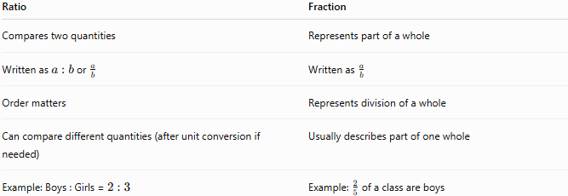
Ratio | Fraction
Compares two quantities | Represents part of a whole
Written as $a:b$or $\frac{a}{b}$ | Written as $\frac{a}{b}$
Order matters | Represents division of a whole
Can compare different quantities (after unit conversion if needed) | Usually describes part of one whole
Example: Boys : Girls = $2:3$ | Example: $\frac{2}{5}$of a class are boys

Ratio vs. Rate
# Source: AI Source: Provided by: [Data Path: Persons Table -> ID Column: 1, Name_En Column: Motasem Essam] -> From: [ChatGPT] on [7/15/2026]
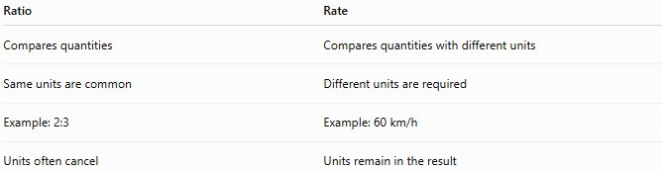
Ratio | Rate
Compares quantities | Compares quantities with different units
Same units are common | Different units are required
Example: 2:3 | Example: 60 km/h
Units often cancel | Units remain in the result

Conclusion
# Source: AI Source: Provided by: [Data Path: Persons Table -> ID Column: 1, Name_En Column: Motasem Essam] -> From: [ChatGPT] on [7/15/2026]
A Ratio is a comparison of two or more quantities using division. It expresses the relative sizes of quantities and can be written using a colon, a fraction, or words. Ratios can be simplified, compared, and used to solve real-world problems involving recipes, maps, engineering, finance, statistics, science, and many other fields. Understanding ratios provides the foundation for learning proportions, rates, percentages, scale drawings, probability, and algebra.

Ratio Change
# Source: AI Source: Provided by: [Data Path: Persons Table -> ID Column: 1, Name_En Column: Motasem Essam] -> From: [ChatGPT] on [7/15/2026]
Ratio Change is the process of modifying one or both quantities in a ratio while determining the resulting ratio. It describes how a ratio changes when quantities are increased, decreased, multiplied, divided, added, or subtracted.
Ratio change is widely used in arithmetic, algebra, geometry, finance, statistics, engineering, economics, and many real-world applications.

Definition
# Source: AI Source: Provided by: [Data Path: Persons Table -> ID Column: 1, Name_En Column: Motasem Essam] -> From: [ChatGPT] on [7/15/2026]
A Ratio Change occurs whenever one or both quantities in a ratio are altered, producing a new ratio.
Suppose the original ratio is
$$\boxed{a:b}$$
If either
- $a$,
- $b$,
or both change, the ratio becomes
$$\boxed{a^{'}:b^{'}}$$
where
- $a^{'}$is the new first quantity,
- $b^{'}$is the new second quantity.

Original Ratio
# Source: AI Source: Provided by: [Data Path: Persons Table -> ID Column: 1, Name_En Column: Motasem Essam] -> From: [ChatGPT] on [7/15/2026]
The original ratio is
$$\boxed{a:b}$$
Equivalent fraction:
$$\boxed{\frac{a}{b}}$$

New Ratio
# Source: AI Source: Provided by: [Data Path: Persons Table -> ID Column: 1, Name_En Column: Motasem Essam] -> From: [ChatGPT] on [7/15/2026]
After the quantities change,
$$\boxed{a^{'}:b^{'}}$$
or
$$\boxed{\frac{a^{'}}{b^{'}}}$$

Types of Ratio Changes
# Source: AI Source: Provided by: [Data Path: Persons Table -> ID Column: 1, Name_En Column: Motasem Essam] -> From: [ChatGPT] on [7/15/2026]
Ratio changes occur when:
- One quantity increases.
- One quantity decreases.
- Both quantities increase.
- Both quantities decrease.
- One quantity is multiplied.
- One quantity is divided.
- A fixed amount is added.
- A fixed amount is subtracted.

Visualizing Ratio Scaling
# Source: AI Source: Provided by: [Data Path: Persons Table -> ID Column: 1, Name_En Column: Motasem Essam] -> From: [ChatGPT] on [7/15/2026]
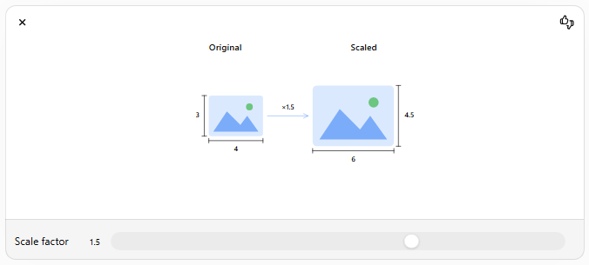This visualization shows how multiplying both quantities by the same factor preserves the ratio.

Case 1 – Multiply Both Quantities by the Same Number
# Source: AI Source: Provided by: [Data Path: Persons Table -> ID Column: 1, Name_En Column: Motasem Essam] -> From: [ChatGPT] on [7/15/2026]
Original ratio:
$$3:5$$
Multiply both by
$$4$$
New ratio:
$$12:20$$
Since
$$\frac{3}{5}=\frac{12}{20},$$
the ratio is equivalent.

Case 2 – Divide Both Quantities by the Same Number
# Source: AI Source: Provided by: [Data Path: Persons Table -> ID Column: 1, Name_En Column: Motasem Essam] -> From: [ChatGPT] on [7/15/2026]
Original ratio:
$$24:36$$
Divide both by
$$12$$
New ratio:
$$2:3$$
Equivalent ratio.

Case 3 – Increase Only One Quantity
# Source: AI Source: Provided by: [Data Path: Persons Table -> ID Column: 1, Name_En Column: Motasem Essam] -> From: [ChatGPT] on [7/15/2026]
Original ratio:
$$4:7$$
Increase first quantity by
$$3$$
New ratio:
$$7:7=1:1$$

Case 4 – Decrease Only One Quantity
# Source: AI Source: Provided by: [Data Path: Persons Table -> ID Column: 1, Name_En Column: Motasem Essam] -> From: [ChatGPT] on [7/15/2026]
Original ratio:
$$10:8$$
Decrease second quantity by
$$3$$
New ratio:
$$10:5=2:1$$

Case 5 – Increase Both Quantities by the Same Amount
# Source: AI Source: Provided by: [Data Path: Persons Table -> ID Column: 1, Name_En Column: Motasem Essam] -> From: [ChatGPT] on [7/15/2026]
Original ratio:
$$3:5$$
Add
$$2$$
to both.
New ratio:
$$5:7$$
Notice:
$$3:5≠5:7$$
Adding the same amount does not preserve the ratio.

Case 6 – Multiply Only One Quantity
# Source: AI Source: Provided by: [Data Path: Persons Table -> ID Column: 1, Name_En Column: Motasem Essam] -> From: [ChatGPT] on [7/15/2026]
Original ratio:
$$2:5$$
Multiply first quantity by
$$3$$
New ratio:
$$6:5$$
The ratio changes completely.

Examples
# Source: AI Source: Provided by: [Data Path: Persons Table -> ID Column: 1, Name_En Column: Motasem Essam] -> From: [ChatGPT] on [7/15/2026]
Example 1
Original ratio:
$$4:9$$
Multiply both numbers by
$$5$$
New ratio:
$$20:45$$
Equivalent ratio.

Example 2
Original ratio:
$$12:18$$
Divide by
$$6$$
New ratio:
$$2:3$$

Example 3
Original ratio:
$$5:8$$
Increase first quantity by
$$3$$
New ratio:
$$8:8=1:1$$

Example 4
Original ratio:
$$9:6$$
Decrease first quantity by
$$3$$
New ratio:
$$6:6=1:1$$

Example 5
Original ratio:
$$7:9$$
Add
$$5$$
to both.
New ratio:
$$12:14=6:7$$

Example 6
Original ratio:
$$15:20$$
Subtract
$$5$$
from both.
New ratio:
$$10:15=2:3$$

Preserving a Ratio
# Source: AI Source: Provided by: [Data Path: Persons Table -> ID Column: 1, Name_En Column: Motasem Essam] -> From: [ChatGPT] on [7/15/2026]
A ratio remains unchanged only when both quantities are multiplied or divided by the same nonzero number.
If
$$a:b$$
becomes
$$ka:kb,$$
then
$$a:b=ka:kb.$$

Changing a Ratio
# Source: AI Source: Provided by: [Data Path: Persons Table -> ID Column: 1, Name_En Column: Motasem Essam] -> From: [ChatGPT] on [7/15/2026]
A ratio changes whenever:
- only one quantity changes,
- unequal amounts are added,
- unequal amounts are subtracted,
- different multiplication factors are used,
- different division factors are used.

Applications
# Source: AI Source: Provided by: [Data Path: Persons Table -> ID Column: 1, Name_En Column: Motasem Essam] -> From: [ChatGPT] on [7/15/2026]
Ratio changes are used in:
- Arithmetic
- Algebra
- Geometry
- Statistics
- Finance
- Economics
- Engineering
- Computer Science
- Chemistry
- Physics

Real-Life Applications
# Source: AI Source: Provided by: [Data Path: Persons Table -> ID Column: 1, Name_En Column: Motasem Essam] -> From: [ChatGPT] on [7/15/2026]
Ratio changes are used in:
- Recipe adjustments
- Currency conversion
- Population comparisons
- Business investments
- Chemical mixtures
- Scale drawings
- Image resizing
- Sports statistics
- Probability
- Financial planning

Real-Life Examples
# Source: AI Source: Provided by: [Data Path: Persons Table -> ID Column: 1, Name_En Column: Motasem Essam] -> From: [ChatGPT] on [7/15/2026]
1. Recipe
Original ratio of flour to sugar:
$$2:3$$
Double both ingredients:
$$4:6$$
The taste remains the same because the ratio is preserved.

2. Classroom
Original boys to girls:
$$12:18$$
Three more boys join:
$$15:18=5:6$$
The ratio changes.

3. Paint Mixing
Original blue to white:
$$4:5$$
Multiply both quantities by
$$3$$
New ratio:
$$12:15$$
Equivalent mixture.

4. Photography
Original image:
$$800×600$$
Resize proportionally:
$$1600×1200$$
The aspect ratio remains
$$4:3.$$

5. Business Investment
Investment ratio:
$$3:2$$
One investor increases only their investment.
The investment ratio changes.

6. Sports
Wins to losses:
$$18:6=3:1$$
After two additional losses:
$$18:8=9:4$$
The ratio changes.

Common Mistakes
# Source: AI Source: Provided by: [Data Path: Persons Table -> ID Column: 1, Name_En Column: Motasem Essam] -> From: [ChatGPT] on [7/15/2026]
- Assuming adding the same number preserves a ratio.
- Confusing equivalent ratios with changed ratios.
- Forgetting to simplify the new ratio.
- Multiplying only one quantity when trying to preserve a ratio.
- Mixing ratios with percentages.

Key Points
# Source: AI Source: Provided by: [Data Path: Persons Table -> ID Column: 1, Name_En Column: Motasem Essam] -> From: [ChatGPT] on [7/15/2026]
- Multiplying or dividing both quantities by the same number preserves the ratio.
- Adding or subtracting the same number usually changes the ratio.
- Changing only one quantity always changes the ratio.
- Always simplify the resulting ratio.
- Ratio changes are widely used in scaling, finance, science, and engineering.

Equivalent Ratio vs. Ratio Change
# Source: AI Source: Provided by: [Data Path: Persons Table -> ID Column: 1, Name_En Column: Motasem Essam] -> From: [ChatGPT] on [7/15/2026]
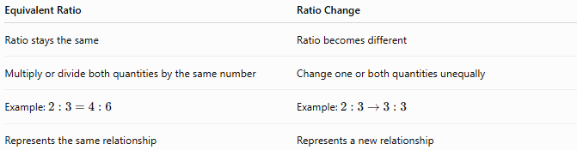
Equivalent Ratio | Ratio Change
Ratio stays the same | Ratio becomes different
Multiply or divide both quantities by the same number | Change one or both quantities unequally
Example: $2:3=4:6$ | Example: $2:3→3:3$
Represents the same relationship | Represents a new relationship

Ratio Change vs. Proportion
# Source: AI Source: Provided by: [Data Path: Persons Table -> ID Column: 1, Name_En Column: Motasem Essam] -> From: [ChatGPT] on [7/15/2026]
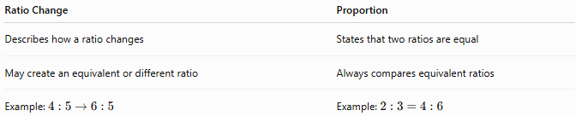
Ratio Change | Proportion
Describes how a ratio changes | States that two ratios are equal
May create an equivalent or different ratio | Always compares equivalent ratios
Example: $4:5→6:5$ | Example: $2:3=4:6$

Conclusion
# Source: AI Source: Provided by: [Data Path: Persons Table -> ID Column: 1, Name_En Column: Motasem Essam] -> From: [ChatGPT] on [7/15/2026]
Ratio Change refers to any modification of one or both quantities in a ratio, resulting in either an equivalent ratio or a new ratio. A ratio is preserved only when both quantities are multiplied or divided by the same nonzero factor. Any unequal modification—such as changing one quantity or adding/subtracting fixed amounts—produces a different ratio. Understanding ratio changes is essential for solving problems involving scaling, recipes, finance, engineering, statistics, geometry, and many other real-world applications.

Proportion
# Source: AI Source: Provided by: [Data Path: Persons Table -> ID Column: 1, Name_En Column: Motasem Essam] -> From: [ChatGPT] on [7/15/2026]
A Proportion is an equation stating that two ratios or two fractions are equal. It expresses that two quantities have the same relative relationship.
Proportions are fundamental in arithmetic and are widely used in algebra, geometry, trigonometry, statistics, finance, engineering, science, computer science, and everyday life.

Definition
# Source: AI Source: Provided by: [Data Path: Persons Table -> ID Column: 1, Name_En Column: Motasem Essam] -> From: [ChatGPT] on [7/15/2026]
A proportion states that two ratios are equal.
If
$$a:b$$
and
$$c:d$$
represent the same ratio, then
$$\boxed{a:b=c:d}$$
or equivalently
$$\boxed{\frac{a}{b}=\frac{c}{d}}$$
provided
$$b≠0,d≠0.$$

Visualizing Proportional Relationships
# Source: AI Source: Provided by: [Data Path: Persons Table -> ID Column: 1, Name_En Column: Motasem Essam] -> From: [ChatGPT] on [7/15/2026]
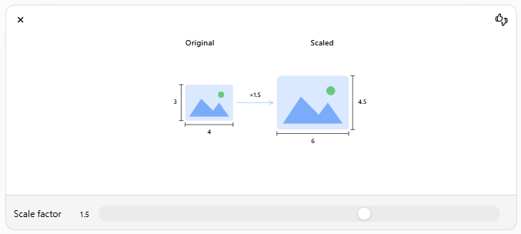
In a proportion, both quantities scale by the same factor while preserving the ratio.

General Form
# Source: AI Source: Provided by: [Data Path: Persons Table -> ID Column: 1, Name_En Column: Motasem Essam] -> From: [ChatGPT] on [7/15/2026]
A proportion is written as
$$\boxed{\frac{a}{b}=\frac{c}{d}}$$
where
- $a$= first term
- $b$= second term
- $c$= third term
- $d$= fourth term

Terms of a Proportion
# Source: AI Source: Provided by: [Data Path: Persons Table -> ID Column: 1, Name_En Column: Motasem Essam] -> From: [ChatGPT] on [7/15/2026]
For
$$\frac{a}{b}=\frac{c}{d}$$
- First Extreme
$$a$$
- First Mean
$$b$$
- Second Mean
$$c$$
- Second Extreme
$$d$$
The means are the middle terms.
The extremes are the outside terms.

Fundamental Property of Proportions
# Source: AI Source: Provided by: [Data Path: Persons Table -> ID Column: 1, Name_En Column: Motasem Essam] -> From: [ChatGPT] on [7/15/2026]
If
$$\frac{a}{b}=\frac{c}{d},$$
then
$$\boxed{ad=bc}$$
This is called cross multiplication.

Solving a Proportion
# Source: AI Source: Provided by: [Data Path: Persons Table -> ID Column: 1, Name_En Column: Motasem Essam] -> From: [ChatGPT] on [7/15/2026]
To solve for an unknown:
Step 1
Cross multiply.

Step 2
Form an equation.

Step 3
Solve for the unknown.

Examples
# Source: AI Source: Provided by: [Data Path: Persons Table -> ID Column: 1, Name_En Column: Motasem Essam] -> From: [ChatGPT] on [7/15/2026]
Example 1
Determine whether
$$\frac{2}{3}=\frac{4}{6}$$
is a proportion.
Cross multiply:
$$2×6=12 \\ 3×4=12$$
Since
$$12=12,$$
it is a proportion.

Example 2
Solve
$$\frac{3}{5}=\frac{x}{20}$$
Cross multiply:
$$3(20)=5x \\ 60=5x \\ x=12$$

Example 3
Solve
$$\frac{8}{12}=\frac{2}{x}$$
Cross multiply:
$$8x=24 \\ x=3$$

Example 4
Solve
$$\frac{x}{15}=\frac{4}{5}$$
Cross multiply:
$$5x=60 \\ x=12$$

Example 5
Determine whether
$$5:8=15:24$$
Cross multiply:
$$5×24=120 \\ 8×15=120$$
Therefore,
the ratios are proportional.

Example 6
Solve
$$\frac{x}{18}=\frac{7}{9}$$
Cross multiply:
$$9x=126 \\ x=14$$

Continued Proportion
# Source: AI Source: Provided by: [Data Path: Persons Table -> ID Column: 1, Name_En Column: Motasem Essam] -> From: [ChatGPT] on [7/15/2026]
Three numbers are in continued proportion if
$$a:b=b:c$$
Example:
$$2:4=4:8$$

Direct Proportion
# Source: AI Source: Provided by: [Data Path: Persons Table -> ID Column: 1, Name_En Column: Motasem Essam] -> From: [ChatGPT] on [7/15/2026]
Two quantities are in direct proportion if they increase or decrease together at the same rate.
$$\boxed{y=kx}$$
where
- $k$is the constant of proportionality.

Inverse Proportion
# Source: AI Source: Provided by: [Data Path: Persons Table -> ID Column: 1, Name_En Column: Motasem Essam] -> From: [ChatGPT] on [7/15/2026]
Two quantities are inversely proportional if one increases while the other decreases so that their product remains constant.
$$\boxed{xy=k}$$
or
$$\boxed{y=\frac{k}{x}}$$

Applications
# Source: AI Source: Provided by: [Data Path: Persons Table -> ID Column: 1, Name_En Column: Motasem Essam] -> From: [ChatGPT] on [7/15/2026]
Proportions are used in:
- Arithmetic
- Algebra
- Geometry
- Trigonometry
- Statistics
- Engineering
- Finance
- Economics
- Science
- Computer Science

Real-Life Applications
# Source: AI Source: Provided by: [Data Path: Persons Table -> ID Column: 1, Name_En Column: Motasem Essam] -> From: [ChatGPT] on [7/15/2026]
Proportions are used in:
- Cooking recipes
- Map scales
- Engineering drawings
- Construction
- Chemical mixtures
- Currency exchange
- Population studies
- Business planning
- Photography
- Computer graphics

Real-Life Examples
# Source: AI Source: Provided by: [Data Path: Persons Table -> ID Column: 1, Name_En Column: Motasem Essam] -> From: [ChatGPT] on [7/15/2026]
1. Recipe Scaling
A recipe needs
2 cups of flour
for
4 servings.
For
10 servings,
solve
$$\frac{2}{4}=\frac{x}{10} \\ x=5$$
cups

2. Map Scale
Map scale:
$$1:100000$$
If
2 cm
are measured,
real distance:
$$200000$$
cm

3. Similar Triangles
If two triangles are similar,
their corresponding sides satisfy proportions.

4. Speed
A car travels
120 km
in
2 hours.
For
5 hours,
distance:
$$\frac{120}{2}=\frac{x}{5} \\ x=300$$
km

5. Paint Mixing
Blue:
3 liters
White:
5 liters
To prepare twice as much paint,
$$6:10$$
maintains the same proportion.

6. Currency Exchange
If
1 USD
equals
50 units
of another currency,
then
$$\frac{1}{50}=\frac{x}{250}$$
gives
$$x=5$$
USD.

Common Mistakes
# Source: AI Source: Provided by: [Data Path: Persons Table -> ID Column: 1, Name_En Column: Motasem Essam] -> From: [ChatGPT] on [7/15/2026]
- Forgetting to cross multiply correctly.
- Mixing the order of the ratios.
- Dividing before simplifying.
- Ignoring zero denominators.
- Confusing ratios with proportions.

Key Points
# Source: AI Source: Provided by: [Data Path: Persons Table -> ID Column: 1, Name_En Column: Motasem Essam] -> From: [ChatGPT] on [7/15/2026]
- A proportion is an equation involving two equal ratios.
- Cross multiplication verifies or solves proportions.
- Means are the middle terms.
- Extremes are the outside terms.
- Proportions describe equivalent ratios.
- Direct and inverse proportions are important special cases.

Ratio vs. Proportion
# Source: AI Source: Provided by: [Data Path: Persons Table -> ID Column: 1, Name_En Column: Motasem Essam] -> From: [ChatGPT] on [7/15/2026]
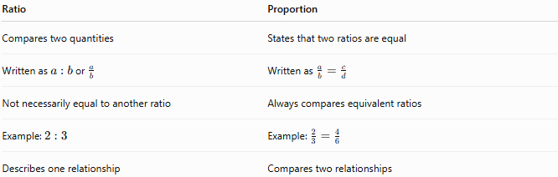
Ratio | Proportion
Compares two quantities | States that two ratios are equal
Written as $a:b$or $\frac{a}{b}$ | Written as $\frac{a}{b}=\frac{c}{d}$
Not necessarily equal to another ratio | Always compares equivalent ratios
Example: $2:3$ | Example: $\frac{2}{3}=\frac{4}{6}$
Describes one relationship | Compares two relationships

Direct Proportion vs. Inverse Proportion
# Source: AI Source: Provided by: [Data Path: Persons Table -> ID Column: 1, Name_En Column: Motasem Essam] -> From: [ChatGPT] on [7/15/2026]
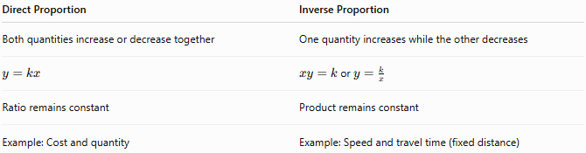
Direct Proportion | Inverse Proportion
Both quantities increase or decrease together | One quantity increases while the other decreases
$$y=kx$$ | $xy=k$or $y=\frac{k}{x}$
Ratio remains constant | Product remains constant
Example: Cost and quantity | Example: Speed and travel time (fixed distance)

Conclusion
# Source: AI Source: Provided by: [Data Path: Persons Table -> ID Column: 1, Name_En Column: Motasem Essam] -> From: [ChatGPT] on [7/15/2026]
A Proportion is an equation showing that two ratios are equal. It is written as an equality of fractions or ratios and is solved using the principle of cross multiplication, where the product of the extremes equals the product of the means. Proportions are essential for solving problems involving scaling, similar figures, map reading, recipes, finance, engineering, science, and countless real-world applications. Understanding proportions provides the foundation for direct proportion, inverse proportion, algebra, geometry, and many advanced mathematical concepts.

Direct Proportion
# Source: AI Source: Provided by: [Data Path: Persons Table -> ID Column: 1, Name_En Column: Motasem Essam] -> From: [ChatGPT] on [7/15/2026]
Direct Proportion (also called Direct Variation) describes a relationship between two quantities that increase or decrease together at the same rate. When one quantity is multiplied or divided by a factor, the other quantity is multiplied or divided by the same factor.
Direct proportion is one of the most important concepts in arithmetic and is widely used in algebra, geometry, physics, engineering, economics, finance, statistics, and everyday life.

Definition
# Source: AI Source: Provided by: [Data Path: Persons Table -> ID Column: 1, Name_En Column: Motasem Essam] -> From: [ChatGPT] on [7/15/2026]
Two quantities are directly proportional if their ratio remains constant.
If one quantity doubles, the other also doubles.
If one quantity triples, the other also triples.
If one quantity is halved, the other is also halved.

Mathematical Definition
# Source: AI Source: Provided by: [Data Path: Persons Table -> ID Column: 1, Name_En Column: Motasem Essam] -> From: [ChatGPT] on [7/15/2026]
If
$$x$$
and
$$y$$
are directly proportional,
then
$$\boxed{y∝x}$$
where
$$∝$$
means "is proportional to."

Direct Proportion Formula
# Source: AI Source: Provided by: [Data Path: Persons Table -> ID Column: 1, Name_En Column: Motasem Essam] -> From: [ChatGPT] on [7/15/2026]
Since the ratio remains constant,
$$\boxed{\frac{y}{x}=k}$$
where
- $k$is the constant of proportionality (also called the proportionality constant).
Rearranging,
$$\boxed{y=kx}$$

Constant of Proportionality
# Source: AI Source: Provided by: [Data Path: Persons Table -> ID Column: 1, Name_En Column: Motasem Essam] -> From: [ChatGPT] on [7/15/2026]
The constant is calculated by
$$\boxed{k=\frac{y}{x}}$$
The value of
$$k$$
remains the same for every pair of corresponding values.

Visualizing Direct Proportion
# Source: AI Source: Provided by: [Data Path: Persons Table -> ID Column: 1, Name_En Column: Motasem Essam] -> From: [ChatGPT] on [7/15/2026]
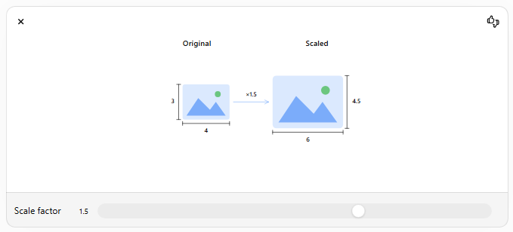
When one quantity is scaled, the other scales by the same factor, preserving a constant ratio.

Properties of Direct Proportion
# Source: AI Source: Provided by: [Data Path: Persons Table -> ID Column: 1, Name_En Column: Motasem Essam] -> From: [ChatGPT] on [7/15/2026]
For directly proportional quantities:
- The ratio
$$\frac{y}{x}$$
is constant.
- The graph is a straight line passing through the origin.
- Both quantities increase together.
- Both quantities decrease together.
- Multiplying one quantity by a factor multiplies the other by the same factor.

Solving Direct Proportion Problems
# Source: AI Source: Provided by: [Data Path: Persons Table -> ID Column: 1, Name_En Column: Motasem Essam] -> From: [ChatGPT] on [7/15/2026]
Step 1
Write the proportional relationship.

Step 2
Use
$$\frac{y_{1}}{x_{1}}=\frac{y_{2}}{x_{2}}$$
or
$$y=kx.$$

Step 3
Solve the unknown.

Examples
# Source: AI Source: Provided by: [Data Path: Persons Table -> ID Column: 1, Name_En Column: Motasem Essam] -> From: [ChatGPT] on [7/15/2026]
Example 1
If
$$5$$
books cost
$$\$40,$$
find the cost of
$$8$$
books.
Write the proportion
$$\frac{40}{5}=\frac{x}{8}$$
Cross multiply
$$5x=320 \\ x=64$$
Answer:
$$\$64$$

Example 2
If
$$3$$
meters of fabric cost
$$\$18,$$
find the cost of
$$7$$
meters.
$$\frac{18}{3}=\frac{x}{7} \\ 3x=126 \\ x=42$$

Example 3
Find the constant of proportionality.
Given
$$x=4,y=20 \\ k=\frac{20}{4}=5$$
Equation:
$$y=5x$$

Example 4
If
$$y=6x,$$
find
$$y$$
when
$$x=9. \\ y=6(9)=54$$

Example 5
A machine produces
$$120$$
parts in
$$4$$
hours.
How many parts in
$$9$$
hours?
$$\frac{120}{4}=\frac{x}{9} \\ 4x=1080 \\ x=270$$

Example 6
A car travels
$$180$$
km in
$$3$$
hours.
How far in
$$8$$
hours (same speed)?
$$\frac{180}{3}=\frac{x}{8} \\ 3x=1440 \\ x=480$$
km

Direct Proportion Table
# Source: AI Source: Provided by: [Data Path: Persons Table -> ID Column: 1, Name_En Column: Motasem Essam] -> From: [ChatGPT] on [7/15/2026]
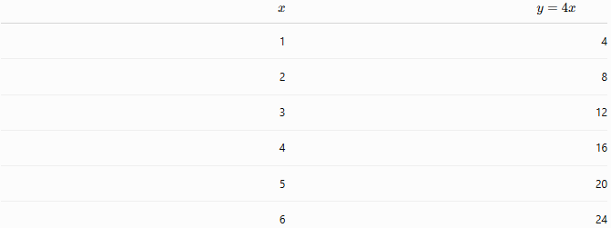
$$x$$ | $$y=4x$$
1 | 4
2 | 8
3 | 12
4 | 16
5 | 20
6 | 24
Notice that
$$\frac{y}{x}=4$$
for every row.

Graph of Direct Proportion
# Source: AI Source: Provided by: [Data Path: Persons Table -> ID Column: 1, Name_En Column: Motasem Essam] -> From: [ChatGPT] on [7/15/2026]
For
$$y=kx,$$
the graph
- is a straight line,
- passes through
$$(0,0),$$
- has slope
$$k.$$

Applications
# Source: AI Source: Provided by: [Data Path: Persons Table -> ID Column: 1, Name_En Column: Motasem Essam] -> From: [ChatGPT] on [7/15/2026]
Direct proportion is used in:
- Arithmetic
- Algebra
- Geometry
- Physics
- Engineering
- Statistics
- Economics
- Finance
- Computer Science
- Chemistry

Real-Life Applications
# Source: AI Source: Provided by: [Data Path: Persons Table -> ID Column: 1, Name_En Column: Motasem Essam] -> From: [ChatGPT] on [7/15/2026]
Direct proportion is used in:
- Shopping costs
- Salary calculations
- Wages
- Distance traveled
- Fuel consumption (constant rate)
- Recipe scaling
- Manufacturing
- Currency exchange
- Printing costs
- Electricity usage

Real-Life Examples
# Source: AI Source: Provided by: [Data Path: Persons Table -> ID Column: 1, Name_En Column: Motasem Essam] -> From: [ChatGPT] on [7/15/2026]
1. Shopping
Each notebook costs
$$\$4.$$
Buying
$$10$$
notebooks costs
$$\$40.$$

2. Salary
A worker earns
$$\$25$$
per hour.
Working
$$8$$
hours earns
$$\$200.$$

3. Recipe
A recipe needs
$$2$$
cups of flour for
$$4$$
people.
For
$$10$$
people:
$$5$$
cups.

4. Printing
One page costs
$$\$0.20.$$
Printing
$$100$$
pages costs
$$\$20.$$

5. Fuel
A car uses
$$8$$
liters every
$$100$$
km.
For
$$300$$
km:
$$24$$
liters.

6. Manufacturing
A machine makes
$$50$$
parts per hour.
In
$$12$$
hours:
$$600$$
parts.

Common Mistakes
# Source: AI Source: Provided by: [Data Path: Persons Table -> ID Column: 1, Name_En Column: Motasem Essam] -> From: [ChatGPT] on [7/15/2026]
- Using direct proportion when the relationship is actually inverse.
- Forgetting that the ratio must remain constant.
- Dividing incorrectly when finding
$$k.$$
- Mixing units without converting them.
- Assuming every increasing relationship is directly proportional.

Key Points
# Source: AI Source: Provided by: [Data Path: Persons Table -> ID Column: 1, Name_En Column: Motasem Essam] -> From: [ChatGPT] on [7/15/2026]
- Direct proportion means both quantities change together.
- The ratio
$$\frac{y}{x}$$
remains constant.
- The equation is
$$y=kx.$$
- The graph is a straight line through the origin.
- Cross multiplication can solve direct proportion problems.

Direct Proportion vs. Inverse Proportion
# Source: AI Source: Provided by: [Data Path: Persons Table -> ID Column: 1, Name_En Column: Motasem Essam] -> From: [ChatGPT] on [7/15/2026]
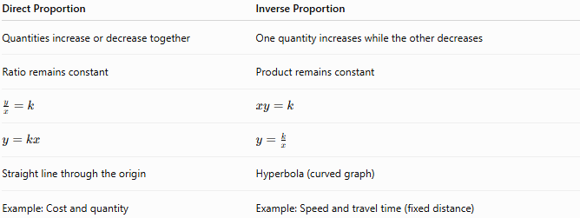
Direct Proportion | Inverse Proportion
Quantities increase or decrease together | One quantity increases while the other decreases
Ratio remains constant | Product remains constant
$$\frac{y}{x}=k$$ | $$xy=k$$
$$y=kx$$ | $$y=\frac{k}{x}$$
Straight line through the origin | Hyperbola (curved graph)
Example: Cost and quantity | Example: Speed and travel time (fixed distance)

Ratio vs. Direct Proportion
# Source: AI Source: Provided by: [Data Path: Persons Table -> ID Column: 1, Name_En Column: Motasem Essam] -> From: [ChatGPT] on [7/15/2026]
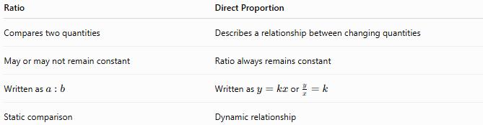
Ratio | Direct Proportion
Compares two quantities | Describes a relationship between changing quantities
May or may not remain constant | Ratio always remains constant
Written as $a:b$ | Written as $y=kx$or $\frac{y}{x}=k$
Static comparison | Dynamic relationship

Conclusion
# Source: AI Source: Provided by: [Data Path: Persons Table -> ID Column: 1, Name_En Column: Motasem Essam] -> From: [ChatGPT] on [7/15/2026]
Direct Proportion describes a relationship in which two quantities change together while maintaining a constant ratio. It is represented by the equation
$$y=kx,$$
where $k$is the constant of proportionality. Direct proportion is essential in arithmetic, algebra, geometry, science, engineering, finance, and many real-world applications such as shopping, wages, recipes, manufacturing, and distance calculations. Understanding direct proportion provides the foundation for studying inverse proportion, linear functions, similarity, scaling, and mathematical modeling.

Inverse Proportion
# Source: AI Source: Provided by: [Data Path: Persons Table -> ID Column: 1, Name_En Column: Motasem Essam] -> From: [ChatGPT] on [7/15/2026]
Inverse Proportion (also called Inverse Variation) describes a relationship between two quantities where one quantity increases while the other decreases, such that their product remains constant.
Inverse proportion is fundamental in arithmetic and is widely used in algebra, geometry, physics, engineering, economics, finance, statistics, computer science, and everyday life.

Definition
# Source: AI Source: Provided by: [Data Path: Persons Table -> ID Column: 1, Name_En Column: Motasem Essam] -> From: [ChatGPT] on [7/15/2026]
Two quantities are inversely proportional if increasing one quantity causes the other quantity to decrease by the same proportional factor.
For example:
- If one quantity doubles, the other is halved.
- If one quantity triples, the other becomes one-third.
- If one quantity is multiplied by 5, the other is divided by 5.

Mathematical Definition
# Source: AI Source: Provided by: [Data Path: Persons Table -> ID Column: 1, Name_En Column: Motasem Essam] -> From: [ChatGPT] on [7/15/2026]
If
$$x$$
and
$$y$$
are inversely proportional,
then
$$\boxed{y∝\frac{1}{x}}$$
where
$$∝$$
means "is proportional to."

Inverse Proportion Formula
# Source: AI Source: Provided by: [Data Path: Persons Table -> ID Column: 1, Name_En Column: Motasem Essam] -> From: [ChatGPT] on [7/15/2026]
The product of the two quantities remains constant.
$$\boxed{xy=k}$$
where
- $k$is the constant of proportionality.
Equivalently,
$$\boxed{y=\frac{k}{x}}$$

Constant of Proportionality
# Source: AI Source: Provided by: [Data Path: Persons Table -> ID Column: 1, Name_En Column: Motasem Essam] -> From: [ChatGPT] on [7/15/2026]
The constant is calculated by
$$\boxed{k=xy}$$
Unlike direct proportion, the product, not the ratio, remains constant.

Visualizing Inverse Proportion
# Source: AI Source: Provided by: [Data Path: Persons Table -> ID Column: 1, Name_En Column: Motasem Essam] -> From: [ChatGPT] on [7/15/2026]
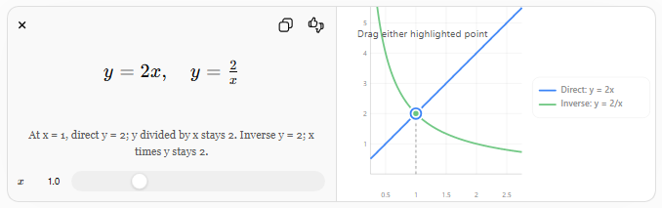
Notice that in an inverse proportion:
- The ratio $\frac{y}{x}$is not constant.
- The product $xy$is constant.

Properties of Inverse Proportion
# Source: AI Source: Provided by: [Data Path: Persons Table -> ID Column: 1, Name_En Column: Motasem Essam] -> From: [ChatGPT] on [7/15/2026]
For inversely proportional quantities:
- The product
$$xy$$
is constant.
- The graph is a curve (hyperbola).
- One quantity increases while the other decreases.
- Multiplying one quantity by a factor divides the other quantity by the same factor.

Solving Inverse Proportion Problems
# Source: AI Source: Provided by: [Data Path: Persons Table -> ID Column: 1, Name_En Column: Motasem Essam] -> From: [ChatGPT] on [7/15/2026]
Step 1
Use
$$xy=k$$
or
$$x_{1}y_{1}=x_{2}y_{2}.$$

Step 2
Substitute the known values.

Step 3
Solve the unknown.

Examples
# Source: AI Source: Provided by: [Data Path: Persons Table -> ID Column: 1, Name_En Column: Motasem Essam] -> From: [ChatGPT] on [7/15/2026]
Example 1
Five workers complete a job in
$$12$$
days.
How many days will
$$10$$
workers need?
Constant:
$$5×12=60$$
Solve:
$$10x=60 \\ x=6$$
days

Example 2
A car travels a fixed distance.
At
$$60$$
km/h it takes
$$5$$
hours.
How long at
$$75$$
km/h?
$$60×5=75x \\ 300=75x \\ x=4$$
hours

Example 3
Find the constant of proportionality.
Given
$$x=8,y=15 \\ k=8×15=120$$
Equation:
$$y=\frac{120}{x}$$

Example 4
If
$$y=\frac{36}{x},$$
find
$$y$$
when
$$x=9. \\ y=\frac{36}{9}=4$$

Example 5
If
$$x=20$$
and
$$y=6,$$
find
$$y$$
when
$$x=8.$$
Constant:
$$20×6=120$$
New value:
$$y=\frac{120}{8}=15$$

Example 6
A water tank is filled by
$$4$$
pipes in
$$15$$
minutes.
How long with
$$12$$
pipes?
$$4×15=12x \\ 60=12x \\ x=5$$
minutes

Inverse Proportion Table
# Source: AI Source: Provided by: [Data Path: Persons Table -> ID Column: 1, Name_En Column: Motasem Essam] -> From: [ChatGPT] on [7/15/2026]
For
$$y=\frac{24}{x}$$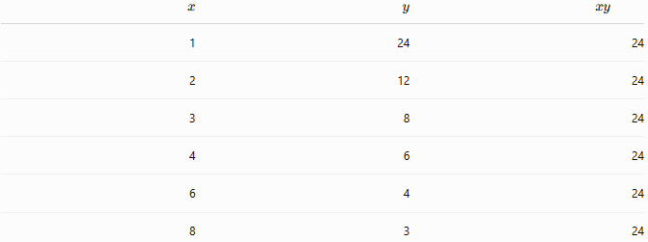
$$x$$ | $$y$$ | $$xy$$
1 | 24 | 24
2 | 12 | 24
3 | 8 | 24
4 | 6 | 24
6 | 4 | 24
8 | 3 | 24
Notice that the product
$$xy=24$$
remains constant.

Graph of Inverse Proportion
# Source: AI Source: Provided by: [Data Path: Persons Table -> ID Column: 1, Name_En Column: Motasem Essam] -> From: [ChatGPT] on [7/15/2026]
For
$$y=\frac{k}{x},$$
the graph:
- is a curve (hyperbola),
- does not pass through the origin,
- approaches both axes but never touches them (when $k≠0$).

Applications
# Source: AI Source: Provided by: [Data Path: Persons Table -> ID Column: 1, Name_En Column: Motasem Essam] -> From: [ChatGPT] on [7/15/2026]
Inverse proportion is used in:
- Arithmetic
- Algebra
- Geometry
- Physics
- Engineering
- Statistics
- Economics
- Finance
- Computer Science
- Chemistry

Real-Life Applications
# Source: AI Source: Provided by: [Data Path: Persons Table -> ID Column: 1, Name_En Column: Motasem Essam] -> From: [ChatGPT] on [7/15/2026]
Inverse proportion is used in:
- Speed and travel time (fixed distance)
- Workers and completion time
- Pipes filling a tank
- Machine production time
- Gas pressure and volume (Boyle's Law)
- Electrical resistance (certain circuits)
- Network load balancing
- Resource allocation
- Manufacturing
- Scheduling

Real-Life Examples
# Source: AI Source: Provided by: [Data Path: Persons Table -> ID Column: 1, Name_En Column: Motasem Essam] -> From: [ChatGPT] on [7/15/2026]
1. Workers
More workers complete the same job in less time.

2. Speed
Higher speed means less travel time for a fixed distance.

3. Pipes
More pipes fill the same tank faster.

4. Machines
More machines reduce production time.

5. Downloading
Increasing internet speed reduces download time for the same file.

6. Project Scheduling
Adding more team members can reduce the time required to complete a fixed amount of work (assuming ideal conditions).

Common Mistakes
# Source: AI Source: Provided by: [Data Path: Persons Table -> ID Column: 1, Name_En Column: Motasem Essam] -> From: [ChatGPT] on [7/15/2026]
- Using direct proportion instead of inverse proportion.
- Assuming the ratio remains constant instead of the product.
- Forgetting that one quantity decreases as the other increases.
- Mixing units without proper conversion.
- Assuming every decreasing relationship is an inverse proportion.

Key Points
# Source: AI Source: Provided by: [Data Path: Persons Table -> ID Column: 1, Name_En Column: Motasem Essam] -> From: [ChatGPT] on [7/15/2026]
- In inverse proportion, one quantity increases while the other decreases.
- The product
$$xy$$
remains constant.
- The equation is
$$y=\frac{k}{x}.$$
- The graph is a hyperbola.
- Cross multiplication using
$$x_{1}y_{1}=x_{2}y_{2}$$
solves inverse proportion problems.

Direct Proportion vs. Inverse Proportion
# Source: AI Source: Provided by: [Data Path: Persons Table -> ID Column: 1, Name_En Column: Motasem Essam] -> From: [ChatGPT] on [7/15/2026]
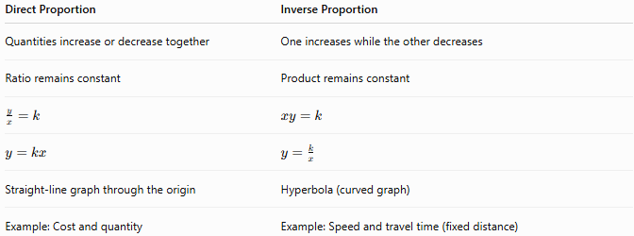
Direct Proportion | Inverse Proportion
Quantities increase or decrease together | One increases while the other decreases
Ratio remains constant | Product remains constant
$$\frac{y}{x}=k$$ | $$xy=k$$
$$y=kx$$ | $$y=\frac{k}{x}$$
Straight-line graph through the origin | Hyperbola (curved graph)
Example: Cost and quantity | Example: Speed and travel time (fixed distance)

Ratio vs. Inverse Proportion
# Source: AI Source: Provided by: [Data Path: Persons Table -> ID Column: 1, Name_En Column: Motasem Essam] -> From: [ChatGPT] on [7/15/2026]
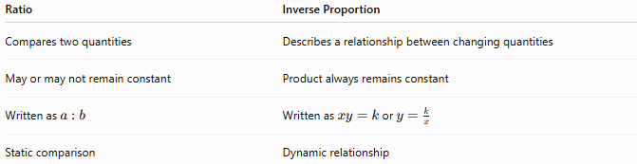
Ratio | Inverse Proportion
Compares two quantities | Describes a relationship between changing quantities
May or may not remain constant | Product always remains constant
Written as $a:b$ | Written as $xy=k$or $y=\frac{k}{x}$
Static comparison | Dynamic relationship

Conclusion
# Source: AI Source: Provided by: [Data Path: Persons Table -> ID Column: 1, Name_En Column: Motasem Essam] -> From: [ChatGPT] on [7/15/2026]
Inverse Proportion describes a relationship in which two quantities change in opposite directions while maintaining a constant product. It is represented by the equations
$$xy=k$$
or
$$y=\frac{k}{x},$$
where $k$is the constant of proportionality. Inverse proportion is essential in arithmetic, algebra, physics, engineering, economics, and many real-world applications involving time, speed, work, pressure, and resource allocation. Understanding inverse proportion provides a strong foundation for functions, graphing, mathematical modeling, and advanced scientific and engineering concepts.

